iGen, Jean Twenge
Chapter 3: In Person No More: I’m with You, but Only Virtually 1
Discussion: 11
Chapter 4: Insecure: The New Mental Health Crisis 11
Discussion: 29

Chapter 3: In Person No More: I’m with You, but Only Virtually

The Screens Go Dark: Mental Health and Happiness
Many people have argued that teens’ communicating with their friends electronically is no big deal—they’re connecting with their friends, so who cares how they do it? In this view, electronic communication is just as good as in-person communication. If so, it would be just as good for mental health and happiness: teens who communicate via social media and text should be just as happy, be just as likely to dodge loneliness, and be just as likely to avoid depression as teens who see their friends in person or engage in other activities that don’t involve screens.
We can find out if that’s true. Let’s start with happiness. The MtF surveys ask teens how happy they are in general (“very happy,” “pretty happy,” or “not very happy”) and also how much time they spend on various activities during their leisure time, including both screen activities such as social networking sites, texting, and Internet time and nonscreen activities such as in-person social interaction, exercise, and print media. Thus we can see which activities create joy and which are more likely to lead to misery.
The results could not be clearer: teens who spend more time on screen activities (the black bars in Figure 3.5) are more likely to be unhappy, and those who spend more time on nonscreen activities (the gray bars) are more likely to be happy. There’s not a single exception: all screen activities are linked to less happiness, and all nonscreen activities are linked to more happiness.
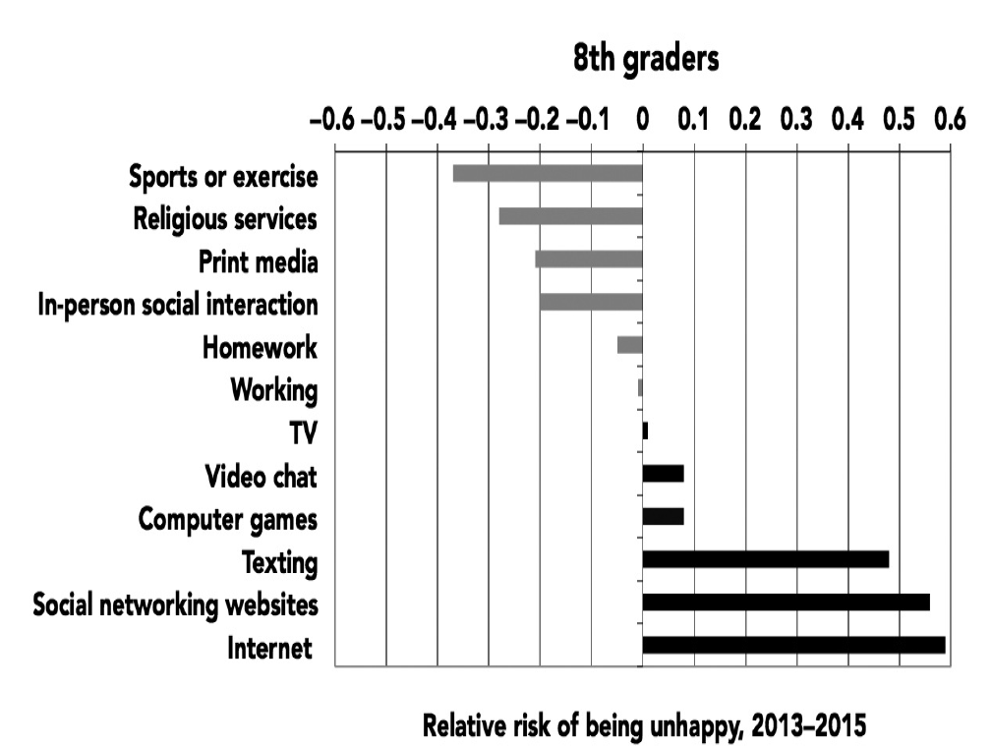
Figure 3.5. Relative risk of being unhappy based on time spent on screen (black bars) and nonscreen (gray bars) activities, 8th graders. Monitoring the Future, 2013–2015.

For example, 8th graders who spend ten or more hours a week on social media are 56% more likely to be unhappy than those who don’t. Admittedly, ten hours a week is a lot—so what about those who spend merely six hours a week or more on social media? They are still 47% more likely to say they are unhappy. But the opposite is true of in-person social interaction: those who spend more time with their friends in person are 20% less likely to be unhappy (listed as –.20 on the chart; see Appendix A for more on relative risk). If you were going to give advice for a happy life based on this graph, it would be straightforward: put down the phone, turn off the computer or iPad, and do something—anything—that does not involve a screen.
These analyses can’t unequivocally prove that screen time causes unhappiness; it’s also possible that unhappy teens spend more time online. However, three recent studies suggest that screen time (particularly social media use) does indeed cause unhappiness. One study asked college students with Facebook pages to complete short surveys on their phones over the course of two weeks—they’d get a text message with a link five times a day and report on their mood and how much they’d used Facebook. The more they’d used Facebook, the unhappier they later felt. However, feeling unhappy did not lead to more Facebook use. Facebook use caused unhappiness, but unhappiness did not cause Facebook use.
Another study of adults found the same thing: the more people used Facebook, the lower their mental health and life satisfaction at the next assessment. But after they interacted with their friends in person, their mental health and life satisfaction improved. A third study randomly assigned 1,095 Danish adults to stop using Facebook for a week (the experimental group) or to continue to use Facebook as usual (the control group). At the end of the week, those who had taken a break from Facebook were happier, less lonely, and less depressed than those who had used Facebook as usual (and by fairly substantial margins—36% fewer were lonely, 33% fewer were depressed, and 9% more were happy). Those who stayed off Facebook were also less likely to feel sad, angry, or worried. Because the participants were randomly assigned to conditions, that rules out the explanation that people who are already unhappy, lonely, or depressed use Facebook more—as a true experiment, it shows that Facebook use causes unhappiness, loneliness, and depression.
The risk of unhappiness due to social media use is the highest for the youngest teens. Eighth graders who spent ten or more hours a week on social networking sites were 56% more likely to be unhappy, compared to 47% for 10th graders and 20% for 12th graders (see Figure 3.6). As vulnerable middle schoolers, 8th graders are still developing their identities and are often struggling with body image issues. Add in cyberbullying online, and it’s a toxic mix. As teens get older, they are less likely to bully one another and more confident in themselves, protecting them somewhat from the slings and arrows of teen social media experience.
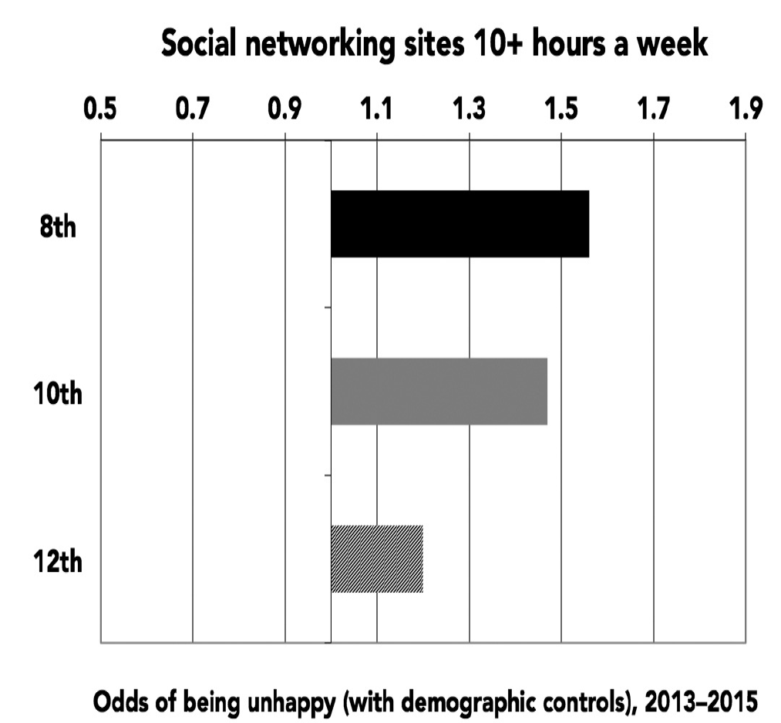
Figure 3.6. Relative risk of being unhappy from spending ten or more hours a week on social networking sites, 8th, 10th, and 12th graders. Monitoring the Future, 2013–2015.

Perhaps there are still some benefits to social media. At least in theory, social media sites are about connecting with others. Maybe using social media doesn’t lead to happiness, but it might still help teens feel more included, more surrounded by friends, and less alone. That’s certainly what social networking sites promise. A recent commercial for Facebook Live advises, “If you have more to say, take out your phone and press this [Facebook icon], tap this [video camera icon] and go live. Now you’re not alone. Your friends are here to listen.” In other words, social media can help us feel less alone and surround us with friends at every moment. If that’s true, teens who spend a lot of time on social media should be less lonely, and social media should be just as good as in-person social interaction when it comes to feeling less lonely.
Unfortunately for the always online iGen, that turns out not to be true. Teens who visit social networking sites every day are actually more likely to agree “I often feel lonely,” “I often feel left out of things,” and “I often wish I had more good friends” (see Figure 3.7; there are fewer activities on this list than for happiness because the loneliness measure is asked on fewer versions of the questionnaire). In contrast, those who spend time with their friends in person or who play sports are less lonely.
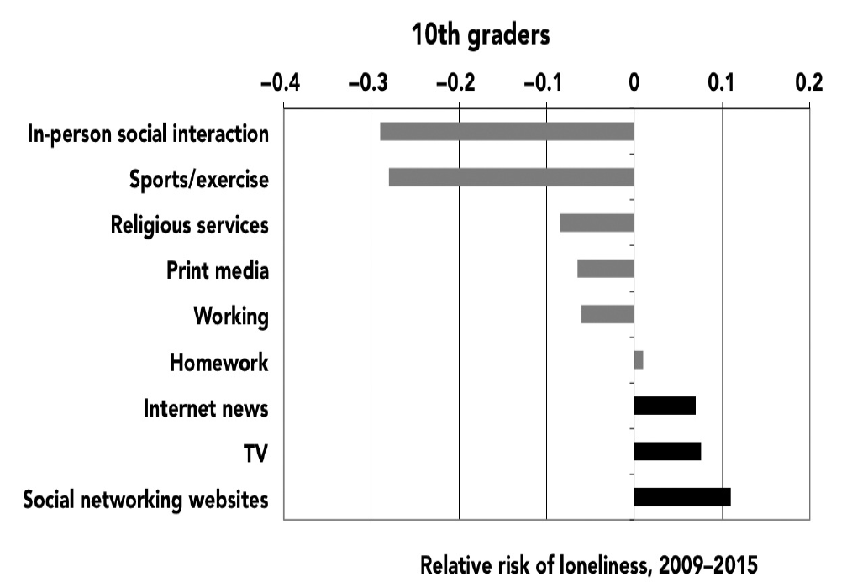
Figure 3.7. Relative risk of loneliness based on time spent on screen (black bars) and nonscreen (gray bars) activities, 10th graders. Monitoring the Future, 2009–2015.

Just as for happiness, the results are clear: screen activities are linked to more loneliness, and nonscreen activities are linked to less loneliness. Teens who spend a lot of time with their friends in person are much less likely to be lonely (with their risk cut nearly in half), and those who visit social networking sites every day or nearly every day are 11% more likely to be lonely. It’s nonscreen activities that help teens feel less alone, not social media. The loneliest teens are those who spend more time on social media and less time with their friends in person.
If social media time reduces in-person social interaction, it may lead to more loneliness through that less direct route as well.
Just as with happiness, it could be that lonely teens use social media more. However, two of the studies mentioned previously both showed that social media use caused loneliness to increase. In addition, the correlation between social media use and loneliness appears across all demographic groups: boys and girls, Hispanics, whites, and blacks, and those both lower and higher in socioeconomic status.
“At school, people are quieter,” confides Olivia, an 18-year-old high school senior. “They all are on their technology ignoring each other. I am dissatisfied with my life because a lot of my friends are addicted to their phones—they seem like they do not want to talk to me because they are on their phones.”
Olivia sounds not just lonely but sad, even depressed. Many parents and educators are concerned that teens who are constantly on their phones might be setting themselves up for depression and other mental health issues. They worry that spending that much time in front of a screen can’t possibly be healthy.
We can find out if those worries are well founded or not. MtF measures symptoms of depression with six items: agreeing with “Life often seems meaningless,” “The future often seems hopeless,” “I feel that I can’t do anything right,” “I feel that my life is not very useful,” and disagreeing with “I enjoy life as much as anyone” and “It feels good to be alive.” A questionnaire like this can’t diagnose clinical-level depression—that must be done by a professional using a structured interview—but it does measure classic symptoms of depression, including hopelessness, lack of meaning, and loss of interest in life.
Once again, the split between screen and nonscreen activities is unmistakable: teens who spend more time on screens are more likely to be depressed, and those who spend more time on nonscreen activities are less likely to be depressed (see Figure 3.8). Eighth graders who are heavy users of social media increase their risk of depression by 27%, while those who play sports, go to religious services, or even do homework cut their risk significantly. The teens who are the most active on social media are also those who are most in danger of developing depression, a mental health issue that devastates millions of US teens each year.
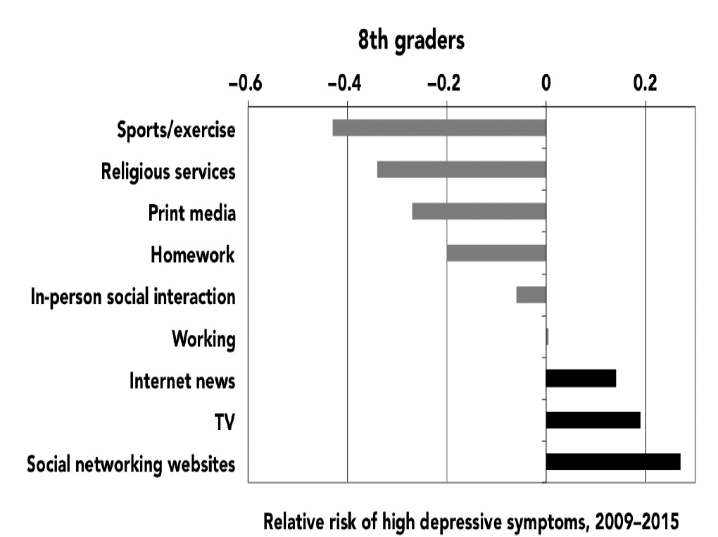
Figure 3.8. Relative risk of high depressive symptoms based on time spent on screen (black bars) and nonscreen (gray bars) activities, 8th graders, 2009–2015.

Younger teens are more at risk for depression connected to heavy social media use. For 10th graders, social media use carries about even odds for depression (see Appendix D). At the very least, social networking sites do not spark joy or protect against depression the way nonscreen activities do; they don’t help and, especially among younger teens, actually hurt.
Ben, 18, lives in Champaign, Illinois, not far from the flagship campus of the University of Illinois. When I reach him one late-August morning, he’s just four days away from beginning his freshman year at a private college in the Northeast. He’s a bookworm who is happy to be heading to a place that takes academics seriously. We chat about the challenges of packing to go away to college and then turn to the topic of social media. “I got my first Facebook [page] at 13,” he says—the minimum age set by the site. “Of course, everyone else already had one.” At that age, he says, social media was a fraught experience. “When I posted stuff, I was always incredibly anxious. I would sit there refreshing to make sure there were likes and stuff,” he says.
“Now my relationship with social media is pretty different. I definitely have more self-confidence, and as a result I sort of care less what people think of my social media. And as a result I basically don’t use it.” He has hit on three truths about social media and teens: their effects on mental health seem to be strongest for the youngest teens, social media can inflame anxiety among those who are susceptible, and those who truly crave the “hit” of likes are often those who are the most vulnerable to mental health issues.
Googling “Facebook and depression” brings up a long list of pages, including a chat board titled “I think Facebook makes me depressed.” MissingGirl, who gives her age as 16 to 17, writes, “Definitely it makes me depressed. All my friends share the fun details of their glamorous lives and it makes me feel like ****. Kinda hate FB.” A poster on Reddit wrote, “Scrolling through my feed, seeing [my friends] being happy makes me sad. Also because . . . I get no messages . . . . The sight of a message box with no notifications gives me a really sad, gut wrenching feeling of loneliness. Facebook depresses me, so I’m going to stop using it.”
Depression is not just a sad mood: if it leads someone to contemplate suicide, it can be physically dangerous as well. The YRBSS (the high school survey administered by the Centers for Disease Control and Prevention) assesses suicide risk, measured by answering “yes” to at least one of the following: feeling very sad and hopeless for two weeks, seriously considering committing suicide, making a plan to commit suicide, or having attempted to commit suicide.
Once again, the link between screen time and mental health issues is distressingly clear: teens who spend more than three hours a day on electronic devices are 35% more likely to have at least one suicide risk factor (see Figure 3.9). That’s much more than the risk related to TV watching, suggesting that it’s not just screens but new media such as smartphones, games, and social media that are behind the link. Nonscreen activities such as exercise instead lower suicide risk factors. So teens who spend a lot of time looking at their phones aren’t just at higher risk of depression—they are also at an alarmingly higher risk for suicide.
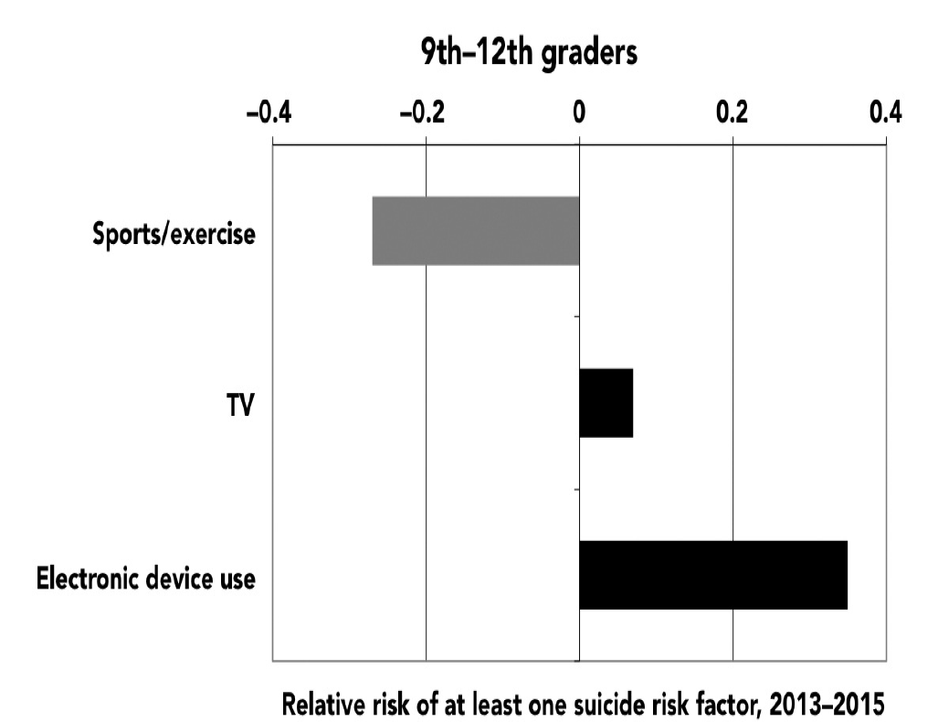
Figure 3.9. Relative risk of having at least one suicide risk factor based on time spent on screen (black bars) and nonscreen (gray bars) activities, 9th–12th graders. Youth Risk Behavior Surveillance System, 2013–2015. (Electronic devices include smartphones, tablets, video games, and computers.)

These analyses show that three hours of screen time a day increases the chance that a teen will be at risk for committing suicide. So how much screen time is too much? Risks start to increase with screen time of two hours or more a day and go up from there, with very high levels of use (five or more hours) linked to considerably higher risks of suicide and unhappiness (see Figure 3.10). This suggests that moderation, not necessarily a complete elimination of electronic devices from teens’ lives, is the key.
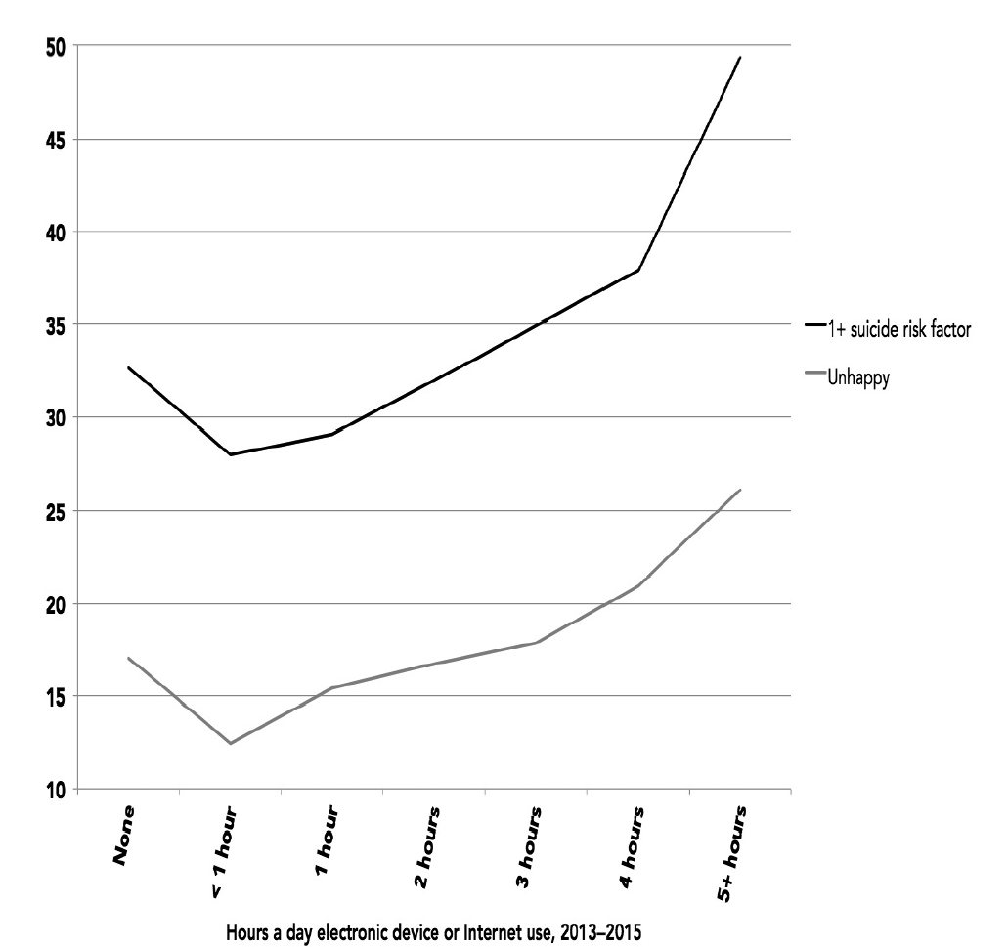
Figure 3.10. Percentage with at least one suicide risk factor and percentage unhappy by hours a day spent on electronic devices or online (exposure-response curve), 9th–12th graders (Youth Risk Behavior Surveillance System), and 8th, 10th, and 12th graders (Monitoring the Future), 2013–2015.

Why is electronic device use linked to such heightened odds of suicide risk? It’s not demographics; the odds look virtually identical when gender, race, and grade are taken into account. It could be that teens at risk for suicide are drawn to electronic devices. Perhaps, but you’d think that those teens, who are often depressed, would be more drawn to passive activities such as TV rather than interactive ones such as social media and computer games. So what, specifically, is so bad about electronic devices that is so much worse than TV? One factor is cyberbullying.
Bullying has always been one of the biggest risk factors for suicide among teens, so it’s not surprising that kids who are bullied at school are twice as likely to have at least one suicide risk factor such as considering suicide or making a suicide plan. However, cyberbullying— electronic bullying via texting, social media, or chat rooms—is even worse (see Figure 3.11).
Two-thirds (66%) of cyberbullied teens have at least one suicide risk factor, 9% more than those who were bullied offline at school. Teens who are cyberbullied often say that there’s no way to get away from their tormentors—unlike with in-person bullies, they can’t just avoid certain people. Unless they give up their phones entirely, the bullying continues.
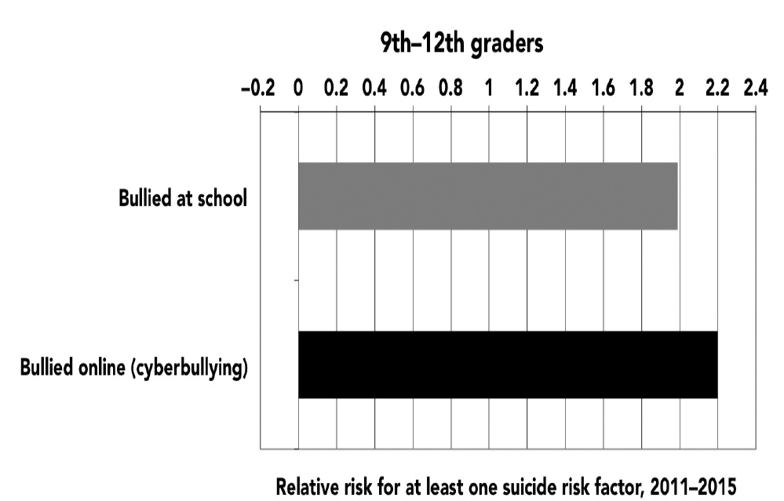
Figure 3.11. Risk of having at least one suicide risk factor based on cyberbullying (black bar) and school bullying (gray bar), 9th–12th graders. Youth Risk Behavior Surveillance System, 2011–2015.

“They said, ‘Nobody likes you, go kill yourself,’ ” 15-year-old Sierra from Virginia said in American Girls about the girls who cyberbullied her. She received one Instagram comment that read, “You have no ass girl, stop trying to take pictures like you have one, it’s not cute, you look like a ho. You look stupid . . . that outfit makes you look like a cheap prostitute that stands on the corner.” The constant bullying sent Sierra into a tailspin. “I started eating ice cream all the time to not let it all get to me, but I don’t want to get fat. So I just solved it by cutting,” she said, referring to self-injury (which involves purposefully cutting yourself with a knife or razor blade, usually on the legs and arms). Eventually, she tried to kill herself, first by swallowing as many pills as she could find and later by jumping in front of an oncoming car. A friend grabbed her and pulled her back.
David Molak was a high school sophomore at Alamo Heights High School in San Antonio, Texas, when his classmates began relentlessly bullying him through text messages, denigrating his physical appearance and hurling other insults. On January 4, 2016, he committed suicide. “I saw the pain in David’s eyes three nights ago as he was added to a group text only to be made fun of and kicked out two minutes later,” his older brother Cliff wrote in a Facebook post. “He stared off into the distance for what seemed like an hour. I could feel his pain . . . . David had been enduring this sort of abuse for a very long time. In today’s age, bullies don’t push you into lockers . . . they cower behind user names and fake profiles from miles away constantly berating and abusing good, innocent people.”
Even when cyberbullying doesn’t lead to suicide, it can certainly lead to unhappiness or depression. Even famous and successful iGen’ers are not immune. Gabby Douglas, the Olympic gymnast who won gold in the all-around competition at the 2012 Games, was cyberbullied after a disappointing performance in 2016. “I wonder how many times I cried. Probably enough to fill so many gallons of water. And it would be like, deep, emotional cries because I was so hurt,” the 21-year-old told People magazine. One set of studies by the Cyberbullying Research Center suggests that cyberbullying has become more common, with 34% of teens in 2016 affected, compared to 19% in 2007. Teens’ entire lives are online, and one out of three is being bullied right where he or she lives.
There’s one last piece of data that indirectly but stunningly captures the move away from inperson activities and toward solo, online interaction. Since 2007, the homicide rate among teens has declined, but the suicide rate has increased. The steady decline in teen homicide from 2007 to 2014 looks very similar to the decline in in-person social interaction (see Figure 3.12). As teens have spent less time with one another in person, they have also become less likely to kill each other. In contrast, teen suicide rates began to tick up after 2008. The rise looks small on the graph because of the scale, but it’s not—46% more teens killed themselves in 2015 than in
2007. The rise occurred just as new-media screen time started to increase and in-person social activities began to wane. In 2011, for the first time in twenty-four years, the teen suicide rate was higher than the teen homicide rate. The gap grew larger from 2011 to 2014, with the suicide rate 32% higher than the homicide rate by 2014—the largest gap since records have been kept (the gap remained high, 30%, in 2015).
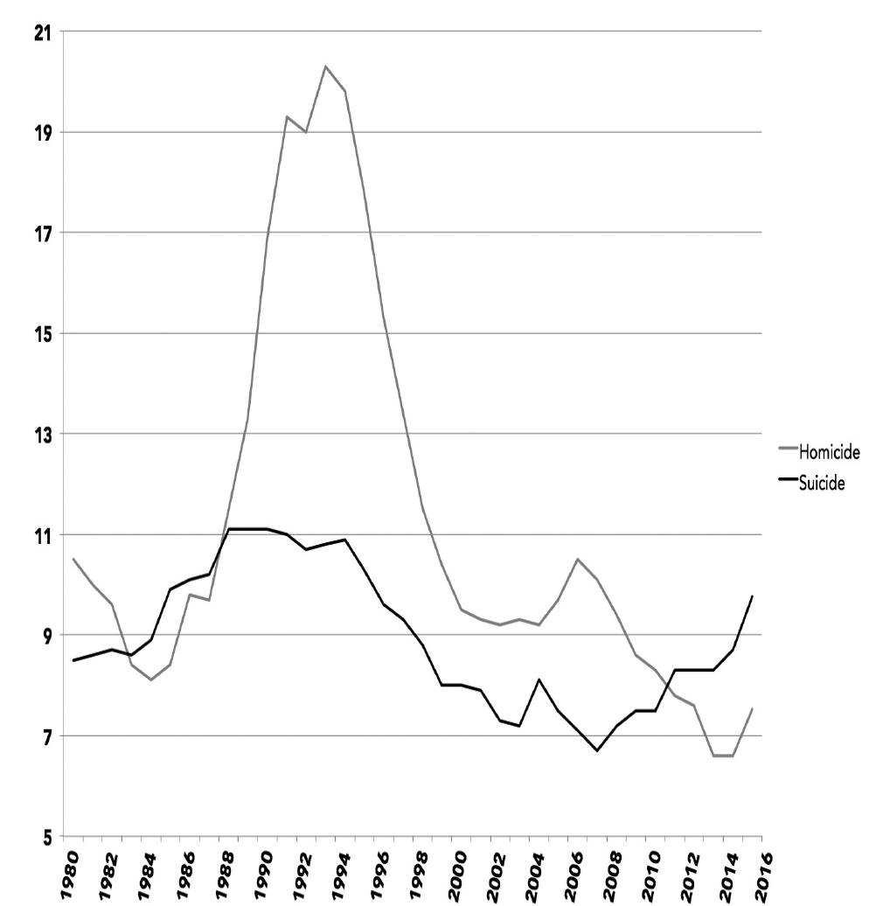
Figure 3.12. Homicide and suicide rates out of 100,000 population among 15- to 19-year-olds, 1980–2015. Centers for Disease Control and Prevention.

The astonishing, though tentative, possibility is that the rise of the smartphone has caused both the decline in homicide and the increase in suicide. With teens spending more hours with their phones and less with their friends, more are becoming depressed and committing suicide and fewer are committing homicide. To put it bluntly: teens have to be with each other in person to kill each other, but they can cyberbully each other into suicide through their phones. Even if bullying is not involved, screen communication can be isolating, which might lead to depression and sometimes suicide. Of course, there are many causes of depression and suicide—too much technology is clearly not the only cause (after all, the suicide rate was even higher in the 1990s, long before smartphones existed). At the same time, it is distressing, and unacceptable, that so many more teens are killing themselves than did just a few years ago.

Caveman Brains, FOMO, and Soft Skills
All in all, in-person social interaction is much better for mental health than electronic communication. This makes sense: humans are inherently social beings, and our brains evolved to crave face-to-face interaction. In hunter-gatherer times, people who got kicked out of the tribe often died because they had no one to share food with (and no one to reproduce with— being a hermit was literally bred out of us). The legacy of this era lives in our brains, which are exquisitely attuned to social acceptance and rejection. I’ve studied this myself: I spent my postdoctoral fellowship researching the effects of social rejection in a series of projects led by the prominent social psychologist Roy Baumeister. We found that even a brief, randomly assigned experience of being socially rejected sent people into a tailspin, increasing aggression, creating feelings of hopelessness, and (my personal favorite) causing them to eat more cookies.
Neuroscientists have found that when people are left out of a game by other players, the brain region involved in physical pain is activated. Apparently it’s not a coincidence that many terms for social pain mimic those for physical pain, including “hurt feelings” and “heartbroken.” (It’s more as though your brain is broken, but the term comes from ancient times when people believed that the heart was the source of our thoughts and feelings.)
With our brains—perhaps especially teen brains—so attuned to social rejection, texting and social media are fertile grounds for negative emotions. Even when things go well, the cadence of electronic communication can be problematic. Unlike in face-to-face interaction, electronic communication often involves a delay between your side of the conversation and your friend’s reply. Think about what happens when you send a text. If the other person doesn’t write back right away, you might wonder why. Is she mad? Did he not like what I said? The same happens when you post something on social media—everyone wants to see the likes, and if they take too long to come or don’t come at all, anxiety can follow.
One study had college students interact in one of two ways: online or in person. Those who interacted in person felt emotionally closer to each other, which makes sense given the conditions under which our human brains evolved. Think about it this way: humans experienced approximately 99.9% of our evolution when the only way to communicate with someone else was in person. Compared to a warm person right in front of you, electronic communication is a pale shadow.
Many iGen’ers say that their online lives make them feel they are walking a tightrope. “I find [social media] really stressful, actually,” 19-year-old Sofia Stojic told the Australian newspaper The Age. “It’s just the knowledge that it’s there in the background. It’s very hard these days to switch it off and be with your thoughts.” The other iGen’ers interviewed in the article all said that they try to turn off notifications or their phone entirely so they can concentrate on other things, such as talking to a friend in person. But they find they can’t, because they fear missing out. “It’s not like you can ever get away from it. You can switch off your phone but it’s still there,” said Amy Bismire, 19.
Even when time on social media goes well and make us feel included, it is no substitute for actual, face-to face interaction. As 17-year-old Kevin says, “If you have contact person to person, you actually get true emotions if you hang out with them. If you do something together, accomplish something together, it just feels good, you know? You get to share emotions, like fighting and making up. You can’t really get those kinds of feelings with social media.”
iGen’ers still yearn for in-person interaction. Nearly all of the 18- and 19-year-olds in the SDSU freshman survey said they would rather see their friends in person than communicate electronically. “It is much more fun to have a conversation in person,” wrote Bailey, 19. “When you are actually with someone it feels so much more personal and loving. Memories are created through experiences and that can’t happen on the phone or computer,” wrote Julian, 18.
For parents, teachers, student affairs professionals, and businesses, the big question is this: Will the decline in in-person social interaction lead to iGen having inferior social skills? Some preliminary evidence suggests it will. In one study, 6th graders spent five days at an overnight nature camp with no access to computers, cell phones, or TV. A control group continued their usual technology activities. All of the kids then took two social skills tests, naming the emotion (happy, sad, angry, fearful) expressed in a series of photos of people’s faces or watching nosound videotapes of social interactions. The kids who had spent five days away from screens improved their social skills significantly more than the control group did.
Athena, 13, thinks that today’s kids are missing out on experienes that develop their social skills. “We grew up with iPhones,” she says. “We don’t know how to communicate like normal people and look people in the eye and talk to them.” Her middle school drama teacher tells students, “Put your phone in the box, we’re learning to look people in the eye.” Athena thinks that phones have affected teen speech as well: “Sometimes it makes us, like, aliens. We don’t know how to talk to people anymore.”
Just as playing the piano takes practice, so do social skills. iGen’ers are not practicing their in-person social skills as much as other generations did, so when it comes time for the “recital” of their social skills, they are more likely to make mistakes onstage when it matters: in college interviews, when making friends in high school, and when competing for a job. Life’s social decisions are still made primarily in person, and iGen gets less experience with such situations. In the next decade we may see more young people who know just the right emoji for a situation
—but not the right facial expression.

Discussion:
- Correlation doesn’t mean causation. However, Twenge seems to argue that excessive screen time causes unhappiness. Do you find her argument persuasive? If so, why? If not, why?
- How might this article inform the way we view the current mental health crisis among young people in America?
- What are some biblical principles you could bring to bear if your child faces cyberbullying?

Chapter 4: Insecure: The New Mental Health Crisis

An Epidemic of Anguish: Major Depressive Disorder, Self-Harm, and Suicide
Madison Holleran was everything most young girls want to grow up to be: beautiful, academically successful, athletic. She was raised in New Jersey, one of five siblings in a closeknit family, and headed off to college at the University of Pennsylvania, where she ran track. Like many college students, she posted pictures on her Instagram page: track meets, friends, parties. “Madison, you look like you’re so happy at this party,” her mother told her. “Mom,” Madison replied. “It’s just a picture.”
Madison’s Instagram account didn’t capture what was really going on: she was depressed. She was, she confided to her friend Emma, scared to grow up, terrified that she didn’t know exactly what would happen next. She had yet to get a driver’s license. After a tough first semester at Penn, she started seeing a therapist near her home in New Jersey. One day in January of her freshman year, her father called and asked if she had found a therapist in Philadelphia so she could continue her treatment when she was at school. “No, but don’t worry, Daddy, I’ll find one,” she said. A few hours later, she jumped off the roof of a nine-story parking garage to her death. She was 19 years old.
So far, what we’ve discussed is variations in symptoms among the normal population: worrisome signs but not evidence of clinical-level depression. Those feelings are still very important, as they affect larger numbers of teens and are risk factors for more serious issues, yet most of the time they don’t rise to the level of a debilitating mental illness. So it’s fair to ask: Has the rise in feelings of loneliness, depression, and anxiety also been accompanied by changes in diagnosable depression and its most extreme outcome, suicide?
The National Survey on Drug Use and Health (NSDUH), conducted by the US Department of Health and Human Services, has screened US teens for clinical-level depression since 2004. The project sends trained interviewers to assess a nationally representative sample of more than 17,000 teens (ages 12 to 17) across the country every year. Participants hear questions through headphones and enter their answers directly into a laptop computer, ensuring privacy and confidentiality. The questions rely on the criteria for major depressive disorder documented in the Diagnostic and Statistical Manual (DSM) of the American Psychiatric Association, the gold standard for diagnosing mental health issues. The criteria include experiencing depressed mood, insomnia, fatigue, or markedly diminished pleasure in life every day for at least two weeks. The study is specifically designed to prove a benchmark for rates of mental illness among Americans, regardless of whether they’ve ever sought treatment. A study like this is about as reliable and valid as you can get.
The screening test shows a shocking rise in depression in a short period of time: 56% more teens experienced a major depressive episode in 2015 than in 2010 (see Figure 4.10), and 60% more experienced severe impairment.
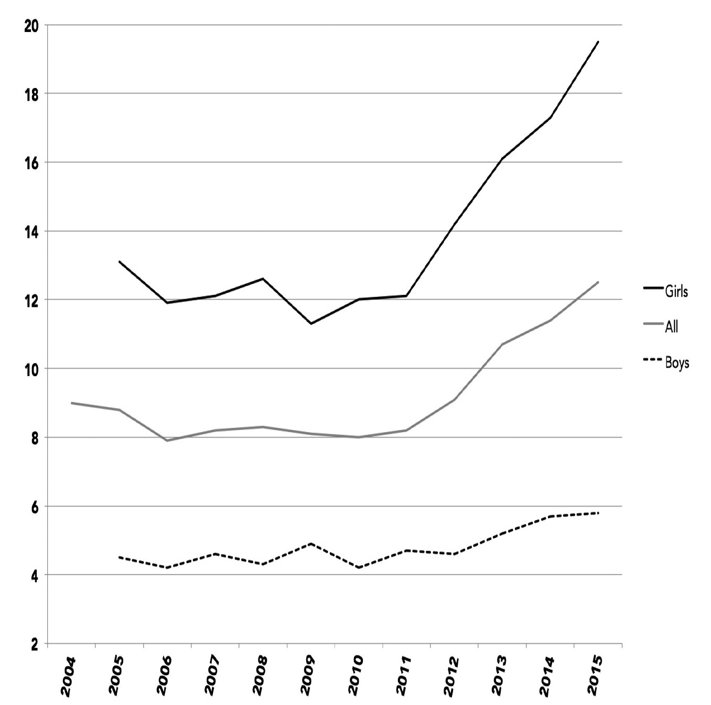
Figure 4.10. Percentage of 12- to 17-year-olds experiencing a major depressive episode or a major depressive episode with severe impairment in the last 12 months, overall and by sex. National Survey on Drug Use and Health, US Department of Health and Human Services, 2004–2015.

More young people are experiencing not just symptoms of depression, and not just feelings of anxiety, but clinically diagnosable major depression. With more than one in nine teens and one in eleven young adults suffering from major depression, this is not a small issue. Even more than the data on rising loneliness and depressive symptoms, these gold-standard data suggest that something is seriously wrong in the lives of American teens.
Suicide, a carefully tracked behavior unaffected by the possible irregularities of self-report surveys, is the most extreme and sadly objective outcome of depression. If suicide rates have risen, it would be strong evidence that depression has reached problematic levels.
Unfortunately, it has. After declining during the 1990s and stabilizing in the 2000s, the suicide rate for teens has risen again. Forty-six percent more 15- to 19-year-olds committed suicide in 2015 than in 2007, and two and a half times more 12- to 14-year-olds killed themselves (see Appendix F). These are heartbreaking numbers.
The rise in suicide is more pronounced for girls. Although the rate increased for both sexes, three times as many 12- to 14-year-old girls killed themselves in 2015 than in 2007, compared to twice as many boys (see Figure 4.11). Although the suicide rate is still higher for boys (likely because they use more lethal methods), girls are beginning to catch up.
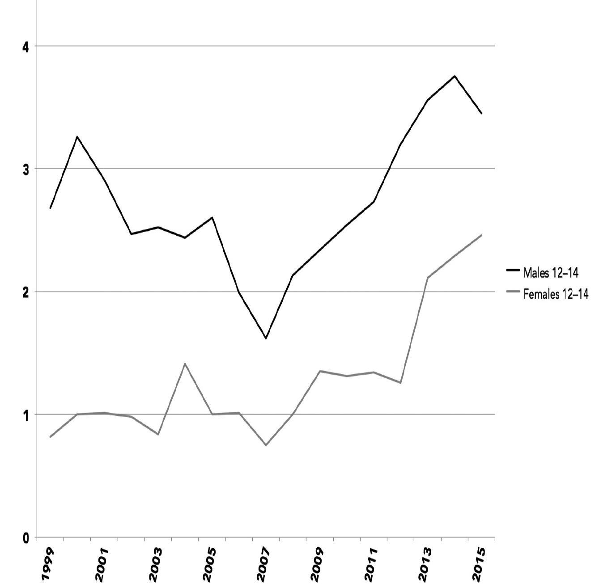
Figure 4.11. Suicide rate per 100,000 people, 12- to 14-year-olds, by sex. Fatal Injury Reports, Centers for Disease Control and Prevention, 1999–2015.

For an outcome such as suicide—the end of a young and precious life—this is an extremely worrisome rise. It’s also surprising, because more Americans now take antidepressants (one out of ten in the last year, more than double the rate of the mid-1990s). Antidepressants are especially effective against severe depression, the type most strongly linked to suicide. Yet they haven’t been enough to stem the growth of suicide among teens that started right around the same time smartphones became common. We can’t say for sure that smartphones are to blame, but the timing is very suspicious. With twice as many young teens killing themselves, something clearly needs to be done.

Why the Rise in Mental Health Issues?
Although the rise in anxiety, depression, and suicide has occurred at the same time as the rise of smartphones, it makes sense to consider other causes as well. An article in The Atlantic blamed teen mental health issues almost exclusively on academic pressure. “Students are challenged to take a demanding course of study, to get a high GPA . . . . School is more challenging,” said one high school counselor. But one good indicator of academic pressure is the amount of time students spend on homework, and as we saw in chapter 1, time spent doing homework is less or about the same as in previous decades, with little change between 2012 and 2016, the years when depression skyrocketed. Plus, as we saw in chapter 3, students who spend more time on homework are actually less likely to be depressed. Thus, it seems highly unlikely that too much time spent studying is the cause of the rise in anxiety and depression.
Other causes also seem unlikely given the available evidence. We can apply a two-part test to possible causes: (1) it must be correlated with mental health issues or unhappiness (see chapter 3) and (2) it must have changed at the same time and in the correct direction. Time spent doing homework fails both tests; it’s not linked to depression, and it didn’t change much over that time period. TV watching is linked to depression, but teens watch less TV now than they used to, so it fails test number two. Time spent on exercise and sports is linked to less depression, but it didn’t change much since 2012, so they fail test number two, too.
Only three activities definitively pass both tests. First, new-media screen time (such as electronic devices and social media) is linked to mental health issues and/or unhappiness, and it rose at the same time. Second and third, in-person social interaction and print media are linked to less unhappiness and less depression, and both have declined at the same time as mental health has deteriorated. A plausible theory includes three possible causes: (1) more screen time has led directly to more unhappiness and depression, (2) more screen time has led to less inperson social interaction, which then led to unhappiness and depression, and (3) more screen time has led to less print media use, leading to unhappiness and depression. In the end, all of the mechanisms come back to new-media screen time in one way or another. By all accounts, it is the worm at the core of the apple.
Of course, even with this evidence, these data can’t definitively show that the shift toward screen time has caused more mental health issues. However, other studies can: experiments that randomly assign people to experience more or less screen time and those that track behavior over time have both found that more screen time causes more anxiety, depression, loneliness, and less emotional connection. It seems clear that at least some of the sudden and large increase in depression has been caused by teens spending more time with screens.
Another possibility is that iGen’ers are unprepared for adolescence and early adulthood due to their lack of independence. With iGen’ers less likely to work, manage their own money, and drive in high school, perhaps they are not developing the resilience that may come from doing things on your own. One study asked college students if their parents “supervised my every move,” “stepped in to solve life problems for me,” and didn’t “let me figure things out independently.” Students whose parents displayed those characteristics (often known as “helicopter parents”) had lower psychological well-being and were more likely to have been prescribed medication for anxiety and depression. Thus, reduced independence passes both tests: it is correlated with mental health issues, and it changed at the same time.
The 2015 song “Stressed Out” by Twenty One Pilots captures this possible link between growing up slowly and mental health issues. In the music video, the band members ride oversized Big Wheels down a suburban Columbus, Ohio, street and drink Capri Suns with straws. Lead singer Tyler Joseph says he wishes they could “turn back time to the good ol’ days when our momma sang us to sleep.” Adulthood is also a sudden, unexpected reality: their parents, they say are “laughing in our face/Saying ‘Wake up, you need to make money.’ ” He thought his fears would go away when he got older, he says, but now he’s insecure and cares what other people think. The song was number two on the Billboard top 100 for 2015, and the video has more than 800 million views on YouTube. As Asbury University student Alyssa Driscoll wrote, the song “has exactly what we’re thinking written in it. . . . [It] really GETS US.”
In the video, Tyler wears black makeup on his neck and hands, which he says is a metaphor for stress. It represents “kind of a feeling of suffocation,” he said in an interview. It makes sense: trying to find your way as an adolescent can be difficult when your childhood was a protected cocoon and you were always told not to care what anyone else thinks. Suddenly it matters what other people think, suddenly you have to be an adult, and that’s stressful. Between student loans and tree houses, he sings, we’d all choose the tree house.

Stealing Sleep
Just before you go to bed, you check on your teen. It looks as though her light is off, but you’re not sure. Then you see it: the faint blue light of her phone as she looks at it in bed.
Many iGen’ers are so addicted to social media that they find it difficult to put down their phones and go to sleep when they should. “I stay up all night looking at my phone,” admits a13-year-old from New Jersey in American Girls. She regularly hides under her covers at night, texting, so her mother doesn’t know she’s awake. She wakes up tired much of the time, but, she says, “I just drink a Red Bull.” Thirteen-year-old Athena told me the same thing: “Some of my friends don’t go to sleep until, like, two in the morning. “I assume just for summer?” I asked.
“No, school, too,” she said. “And we have to get up at six forty-five.”
Smartphone use may have decreased teens’ sleep time: more teens now sleep less than seven hours most nights (see Figure 4.12). Sleep experts say that teens should get about nine hours of sleep a night, so a teen who is getting less than seven hours a night is significantly sleep deprived. Fifty-seven percent more teens were sleep deprived in 2015 than in 1991. In just the three years between 2012 and 2015, 22% more teens failed to get seven hours of sleep.
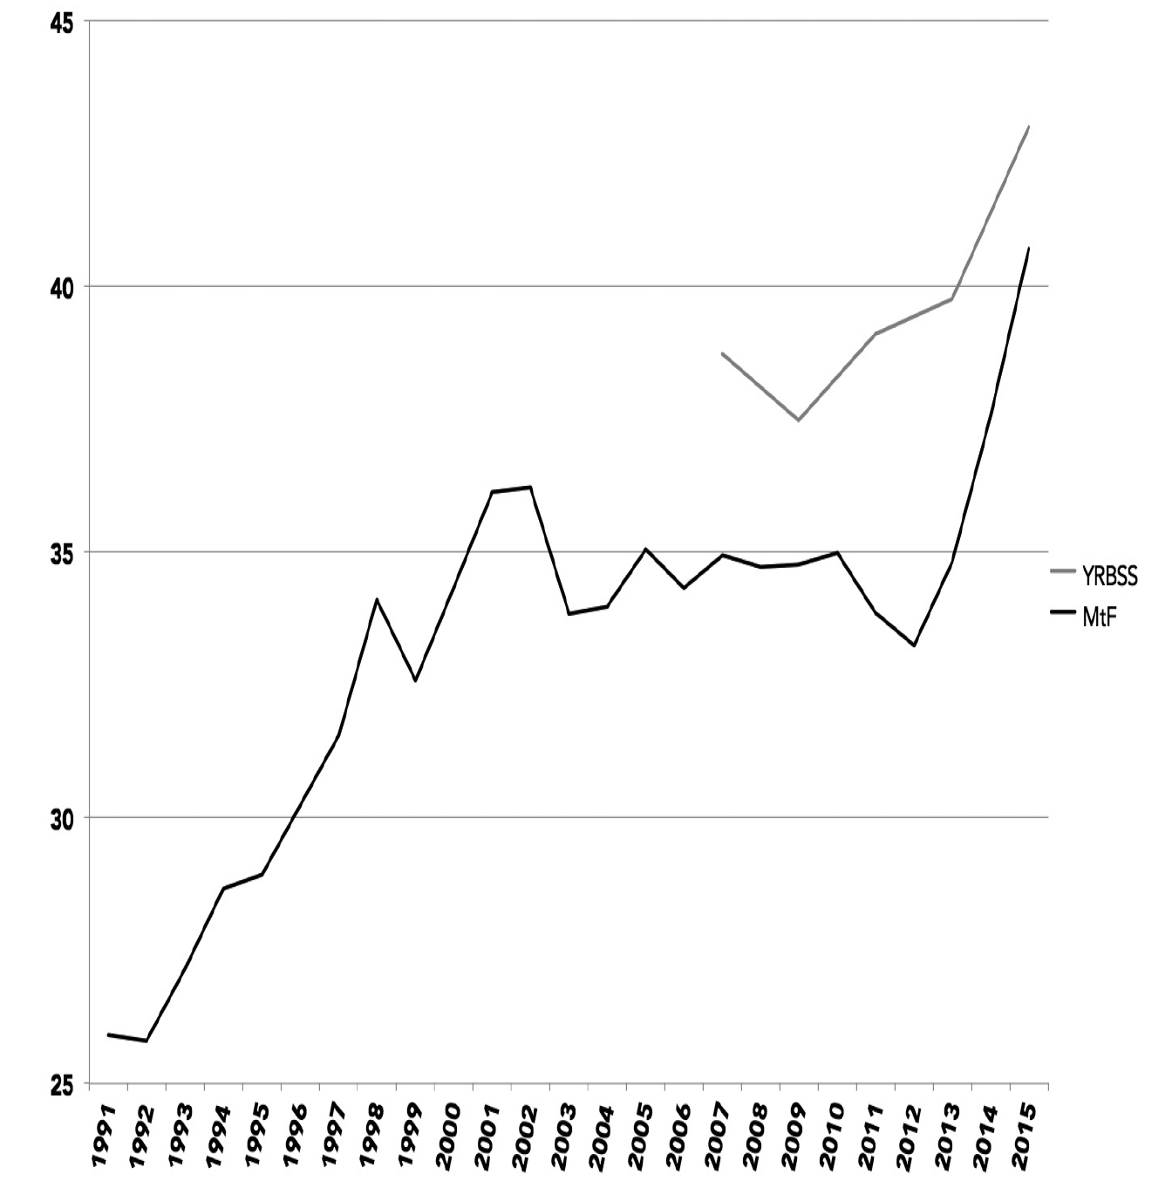
Figure 4.12. Percentage of teens who get less than seven hours of sleep on most nights, 8th, 10th, and 12th graders (Monitoring the Future) and 9th to 12th graders (Youth Risk Behavior Surveillance System), 1991–2015.

As always, it’s difficult to say for sure what the cause is in a trend over time. Still, the timing of the increase is suspicious, once again occurring just as most teens began to have smartphones, around 2011 or 2012. The increase is also larger for girls than for boys (see Appendix F), and girls are more active on social media.
If teens who spent more time online also slept less, that would be further evidence that new media and smartphones might be behind the lack of sleep. That is indeed the case: teens who spent three or more hours a day on electronic devices were 28% more likely to get less than seven hours of sleep, and teens who visited social media sites every day were 19% more likely not to get adequate sleep (see Figure 4.13). The number of teens who don’t sleep enough goes up after two or more hours a day of electronic device use and skyrockets from there (see Appendix F). An extensive meta-analysis of studies on electronic device use among children found similar results: children who used a media device before bed were more likely to sleep less than they should, more likely to sleep poorly, and more than twice as likely to be sleepy during the day.
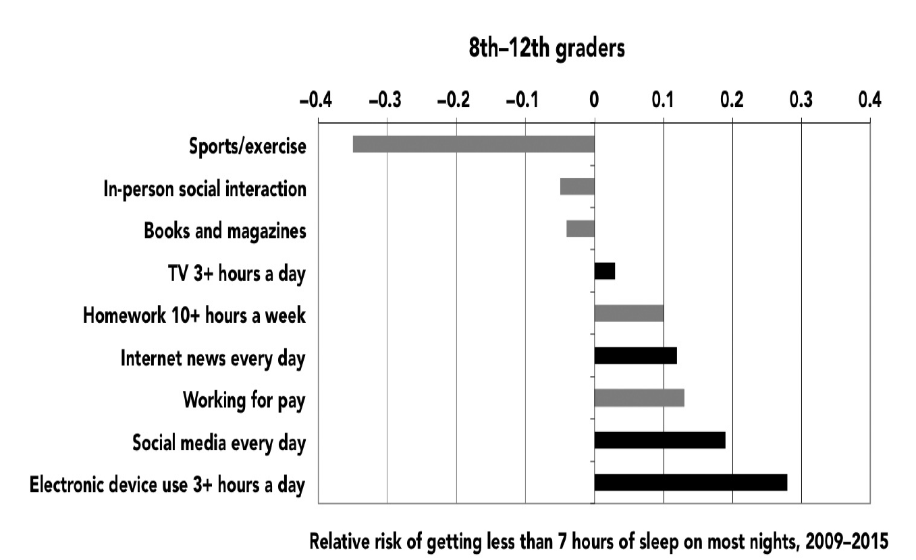
Figure 4.13. Relative risk of getting less than seven hours of sleep on most nights based on screen (black bars) and nonscreen (gray bars) activities. Monitoring the Future and Youth Risk Behavior Surveillance System, 2009–2015.

Electronic devices and social media seem to be unique in their effect on sleep compared to older forms of media. Teens who read books and magazines more often are actually less likely to be sleep deprived—either reading puts them to sleep, or they can put the book down at bedtime. TV time is barely related to sleep time. Apparently, teens who watch a lot of TV can turn it off and go to sleep, while those on their phones do not. The allure of the smartphone, its blue light glowing in the dark, is often too much to resist.
Other activities that take up a lot of time, such as homework and working for pay, also increase the risk of missing out on sleep. But since teens spent about the same amount of time working and on homework in 2015 as they did in 2012, those activities are unlikely to be the cause of the increase in sleep deprivation since 2012. Other activities that take time, such as exercising and spending time with friends in person, actually correlate with getting more sleep.
New-media use is both the most strongly related to sleep deprivation and the only activity that increased significantly between 2012 and 2015. Thus, smartphones appear to be the primary cause of the recent increase in sleep deprivation, which means this new technology has adversely affected physical health as well as mental health.
Lack of sleep can have serious consequences. Sleep deprivation is linked to myriad issues, including compromised thinking and reasoning, susceptibility to illness, increased weight gain, and high blood pressure. Sleep deprivation also has a significant effect on mood: people who don’t sleep enough are prone to depression and anxiety.
Sound familiar? Lack of sleep might be another reason why iGen’ers are more likely to be depressed. Teens who don’t sleep enough are more than twice as likely to report higher levels of depressive symptoms (31% do, versus only 12% for those who sleep more). Teens who sleep less than seven hours a night are also 68% more likely to have at least one risk factor for suicide (see Figure 4.14). Sleep deprivation is the ultimate buzzkill to mood, and over time it can snowball into serious mental health issues.
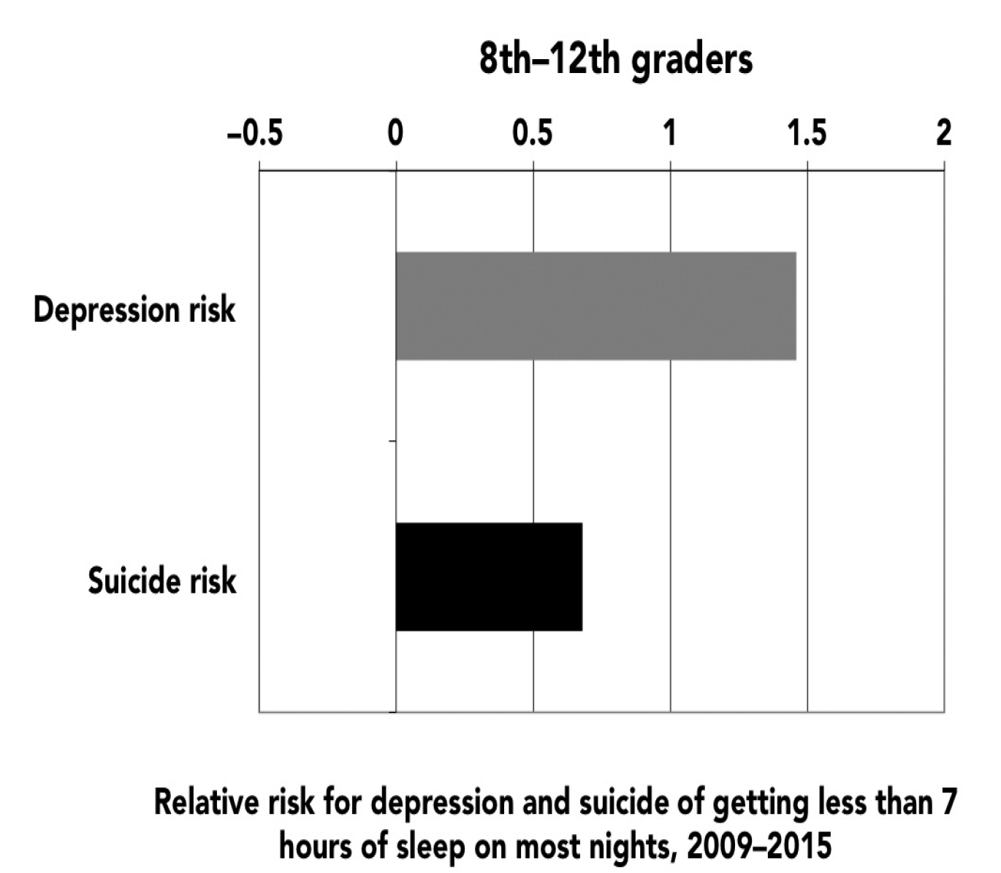
Figure 4.14. Relative risk of having a high level of depressive symptoms or having at least one suicide risk factor based on sleeping less than seven hours on most nights, 8th and 10th graders (Monitoring the Future) and 9th to 12th graders (Youth RiskSurveillance System), 2009–2015.

These risks look almost identical across gender, race, and socioeconomic status, so those factors are not the cause. Intriguing new research shows that the blue light emitted by electronic devices tells our brains it’s still daytime, which makes the brain take longer to fall asleep. It probably doesn’t help that social media exchanges, especially for teen girls, are filled with drama, not the best thing when you’re trying to relax before bed. So smartphones could be causing lack of sleep, which leads to depression, or the phones could be causing depression, which leads to lack of sleep. It’s all rooted in the allure of the phone: when the phone calls its siren song, teens crash into the rocks instead of crashing into their beds.

What Can We Do?
According to his parents, Brian Go, a junior at Caltech, wrote an email to a counselor at the university’s counseling center asking for help. After a breakup with a girlfriend, he wasn’t sure he had the “will to go on,” he wrote. The counselor told him she couldn’t get him an appointment for several more days. Soon afterward, he killed himself.
Caltech disputed that account, maintaining that Brian had denied that he continued to have suicidal feelings. Nevertheless, the case highlights a nationwide problem: the often inadequate resources for mental health assistance on college campuses. Waiting lists for appointments with therapists can be long, and budget cuts have meant fewer staff to minister to more students seeking help. Many campus counseling centers have limits on how many times students can see on-campus therapists. After Shefali Arora ran through the twelve sessions of on-campus therapy allowed for each student at Tulane University, the office handed her a list of off-campus therapists. “But I didn’t have a car,” she said. After taking a semester of medical leave, she attempted suicide but, thankfully, did not succeed.
High school students and their parents are already seeking help for psychological issues at an unprecedented rate. In 1983, only 4% of high school seniors (in the MtF survey) had seen a professional for psychological or emotional issues in the past twelve months. That figure doubled to 8% by 2000 and then rose to 11% in 2015. Thus mental health providers are experiencing a larger caseload than in years past, a trend that is likely to continue. Practitioners need to prepare for an increasing wave of iGen clients.
The bigger problem will occur if young people don’t seek help. In college newspapers, iGen’ers themselves are sounding the alarm, calling for more recognition of mental illness and less stigma around it. “I worry about the lack of understanding that always seems to accompany any talk of one’s emotional well-being,” wrote Logan Jones in the Utah State student newspaper. “. . . Seeing a therapist is still taboo. . . . Nobody likes the idea of putting a label on what can so easily be written off as some form of insecurity—nobody wants to be diagnosed.”
More often than not, depression goes untreated. Even in our age of greater awareness of mental illness, Cooper Lund argues in the Daily Oklahoman, depression is still stigmatized and undertreated. “If I thought I might have cancer, I’d go running to the doctor, but when I thought I had depression it took me four years to finally see a psychiatrist,” he admitted.
Help for mental health issues is essential, but of course it would be even better to stop depression and anxiety before they start. To do that, it would help to know what causes these mental health issues in the first place. Though some people have genetic predispositions to anxiety and depression, the abrupt rise in mental health issues strongly suggests that genetics is not the whole story. Recent research confirms this, finding that genetics and environment interact. Among those predisposed to depression, only those who experience certain environments will actually become depressed. For example, sleep deprivation is linked to depression; as we saw, teens are not getting enough sleep, and that’s probably one reason why more are depressed. The decline of in-person social interaction and the rise of smartphones are likely another reason. In other words, there is a simple, free way to improve mental health: put down the phone, and do something else.

Discussion:
- Twenge argues that “Helicopter Parenting” stifles independence, which correlates to lower psychological well-being. Why do you think the “Helicopter Parenting” style has such adverse effects upon children?
- What are some biblical principles you could bring to bear if your child expresses feeling or despair and worthless?
- How might social media exasperate feelings of insecurity? How might it create anxiety?
- How might this article alter your approach to your child’s screen time?
- What are some practical guidelines you could put in place to moderate your child’s screen time?
- How might you handle your teenager’s insistence that you buy him/her a smartphone because “all of his/her friends have one?”

