iGen, Jean Twenge

The Screens Go Dark: Mental Health and Happiness
Many people have argued that teens’ communicating with their friends electronically is no big deal—they’re connecting with their friends, so who cares how they do it? In this view, electronic communication is just as good as in-person communication. If so, it would be just as good for mental health and happiness: teens who communicate via social media and text should be just as happy, be just as likely to dodge loneliness, and be just as likely to avoid depression as teens who see their friends in person or engage in other activities that don’t involve screens.
We can find out if that’s true. Let’s start with happiness. The MtF surveys ask teens how happy they are in general (“very happy,” “pretty happy,” or “not very happy”) and also how much time they spend on various activities during their leisure time, including both screen activities such as social networking sites, texting, and Internet time and nonscreen activities such as in-person social interaction, exercise, and print media. Thus we can see which activities create joy and which are more likely to lead to misery.
The results could not be clearer: teens who spend more time on screen activities (the black bars in Figure 3.5) are more likely to be unhappy, and those who spend more time on nonscreen activities (the gray bars) are more likely to be happy. There’s not a single exception: all screen activities are linked to less happiness, and all nonscreen activities are linked to more happiness.
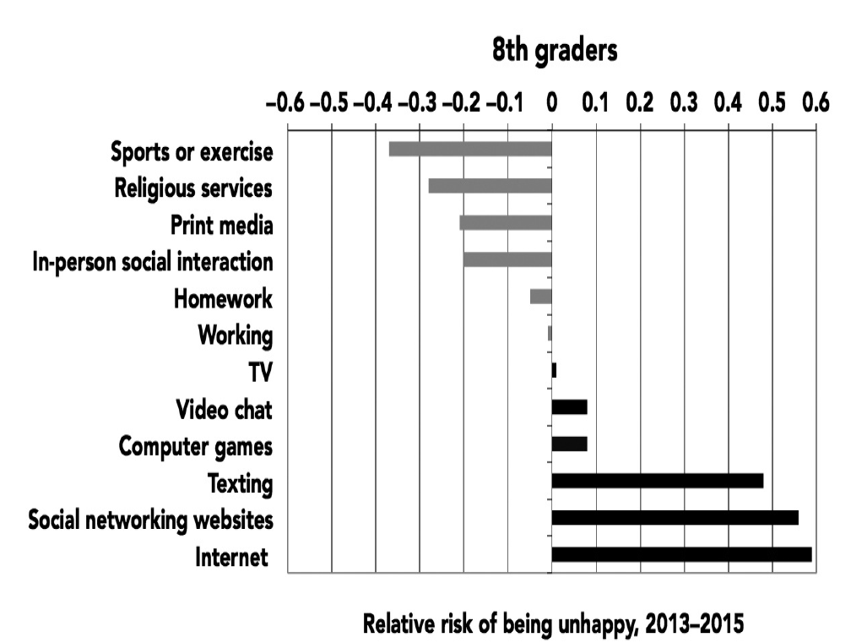
Figure 3.5. Relative risk of being unhappy based on time spent on screen (black bars) and nonscreen (gray bars) activities, 8th graders. Monitoring the Future, 2013–2015.

For example, 8th graders who spend ten or more hours a week on social media are 56% more likely to be unhappy than those who don’t. Admittedly, ten hours a week is a lot—so what about those who spend merely six hours a week or more on social media? They are still 47% more likely to say they are unhappy. But the opposite is true of in-person social interaction: those who spend more time with their friends in person are 20% less likely to be unhappy (listed as –.20 on the chart; see Appendix A for more on relative risk). If you were going to give advice for a happy life based on this graph, it would be straightforward: put down the phone, turn off the computer or iPad, and do something—anything—that does not involve a screen.
These analyses can’t unequivocally prove that screen time causes unhappiness; it’s also possible that unhappy teens spend more time online. However, three recent studies suggest that screen time (particularly social media use) does indeed cause unhappiness. One study asked college students with Facebook pages to complete short surveys on their phones over the course of two weeks—they’d get a text message with a link five times a day and report on their mood and how much they’d used Facebook. The more they’d used Facebook, the unhappier they later felt. However, feeling unhappy did not lead to more Facebook use. Facebook use caused unhappiness, but unhappiness did not cause Facebook use.
Another study of adults found the same thing: the more people used Facebook, the lower their mental health and life satisfaction at the next assessment. But after they interacted with their friends in person, their mental health and life satisfaction improved. A third study randomly assigned 1,095 Danish adults to stop using Facebook for a week (the experimental group) or to continue to use Facebook as usual (the control group). At the end of the week, those who had taken a break from Facebook were happier, less lonely, and less depressed than those who had used Facebook as usual (and by fairly substantial margins—36% fewer were lonely, 33% fewer were depressed, and 9% more were happy). Those who stayed off Facebook were also less likely to feel sad, angry, or worried. Because the participants were randomly assigned to conditions, that rules out the explanation that people who are already unhappy, lonely, or depressed use Facebook more—as a true experiment, it shows that Facebook use causes unhappiness, loneliness, and depression.
The risk of unhappiness due to social media use is the highest for the youngest teens. Eighth graders who spent ten or more hours a week on social networking sites were 56% more likely to be unhappy, compared to 47% for 10th graders and 20% for 12th graders (see Figure 3.6). As vulnerable middle schoolers, 8th graders are still developing their identities and are often struggling with body image issues. Add in cyberbullying online, and it’s a toxic mix. As teens get older, they are less likely to bully one another and more confident in themselves, protecting them somewhat from the slings and arrows of teen social media experience.
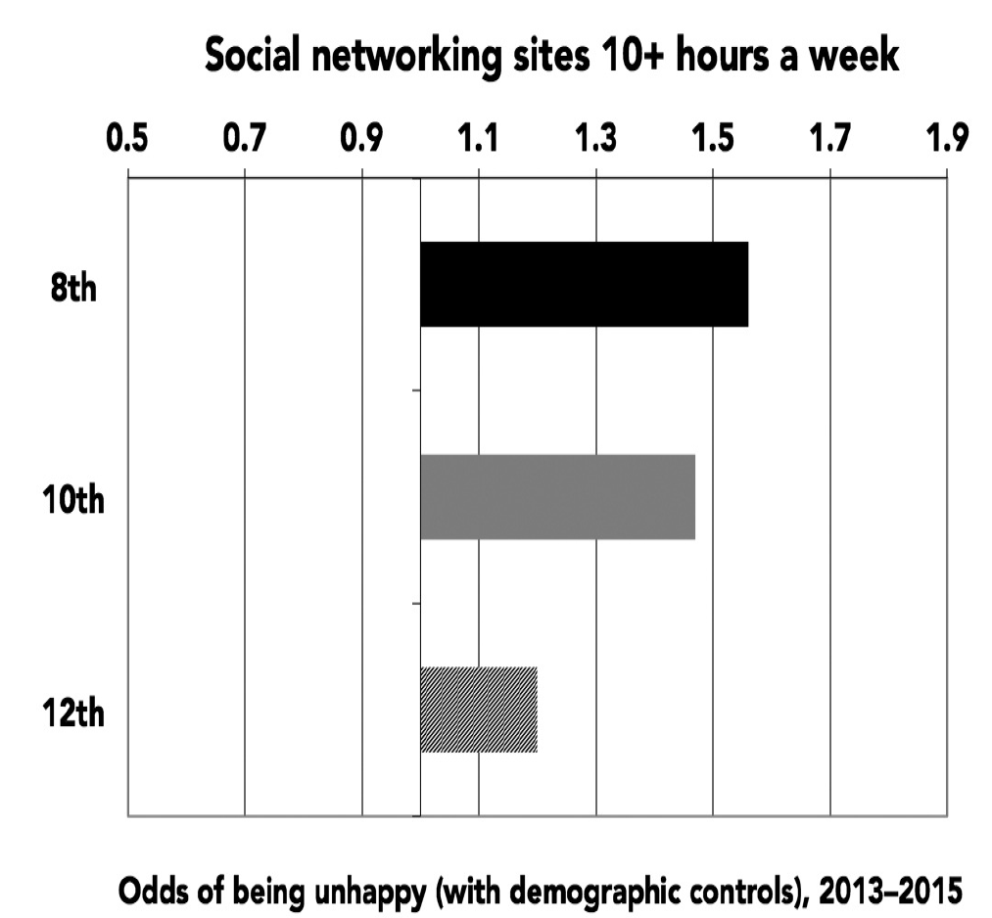
Figure 3.6. Relative risk of being unhappy from spending ten or more hours a week on social networking sites, 8th, 10th, and 12th graders. Monitoring the Future, 2013–2015.

Perhaps there are still some benefits to social media. At least in theory, social media sites are about connecting with others. Maybe using social media doesn’t lead to happiness, but it might still help teens feel more included, more surrounded by friends, and less alone. That’s certainly what social networking sites promise. A recent commercial for Facebook Live advises, “If you have more to say, take out your phone and press this [Facebook icon], tap this [video camera icon] and go live. Now you’re not alone. Your friends are here to listen.” In other words, social media can help us feel less alone and surround us with friends at every moment. If that’s true, teens who spend a lot of time on social media should be less lonely, and social media should be just as good as in-person social interaction when it comes to feeling less lonely.
Unfortunately for the always online iGen, that turns out not to be true. Teens who visit social networking sites every day are actually more likely to agree “I often feel lonely,” “I often feel left out of things,” and “I often wish I had more good friends” (see Figure 3.7; there are fewer activities on this list than for happiness because the loneliness measure is asked on fewer versions of the questionnaire). In contrast, those who spend time with their friends in person or who play sports are less lonely.
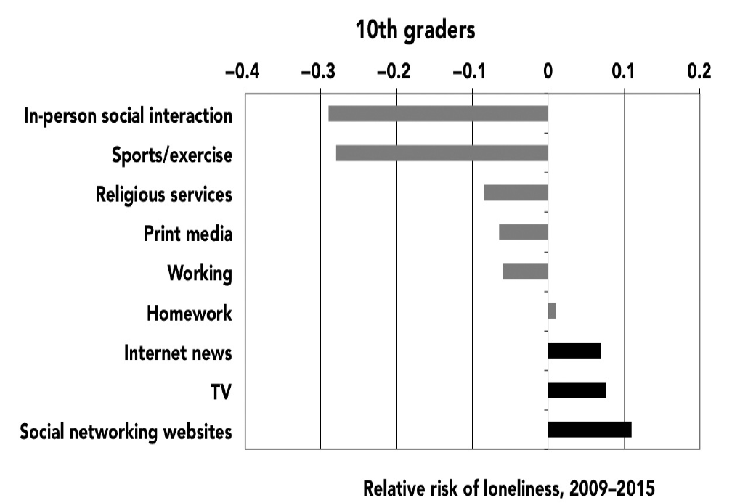
Figure 3.7. Relative risk of loneliness based on time spent on screen (black bars) and nonscreen (gray bars) activities, 10th graders. Monitoring the Future, 2009–2015.

Just as for happiness, the results are clear: screen activities are linked to more loneliness, and nonscreen activities are linked to less loneliness. Teens who spend a lot of time with their friends in person are much less likely to be lonely (with their risk cut nearly in half), and those who visit social networking sites every day or nearly every day are 11% more likely to be lonely. It’s nonscreen activities that help teens feel less alone, not social media. The loneliest teens are those who spend more time on social media and less time with their friends in person.
If social media time reduces in-person social interaction, it may lead to more loneliness through that less direct route as well.
Just as with happiness, it could be that lonely teens use social media more. However, two of the studies mentioned previously both showed that social media use caused loneliness to increase. In addition, the correlation between social media use and loneliness appears across all demographic groups: boys and girls, Hispanics, whites, and blacks, and those both lower and higher in socioeconomic status.
“At school, people are quieter,” confides Olivia, an 18-year-old high school senior. “They all are on their technology ignoring each other. I am dissatisfied with my life because a lot of my friends are addicted to their phones—they seem like they do not want to talk to me because they are on their phones.”
Olivia sounds not just lonely but sad, even depressed. Many parents and educators are concerned that teens who are constantly on their phones might be setting themselves up for depression and other mental health issues. They worry that spending that much time in front of a screen can’t possibly be healthy.
We can find out if those worries are well founded or not. MtF measures symptoms of depression with six items: agreeing with “Life often seems meaningless,” “The future often seems hopeless,” “I feel that I can’t do anything right,” “I feel that my life is not very useful,” and disagreeing with “I enjoy life as much as anyone” and “It feels good to be alive.” A questionnaire like this can’t diagnose clinical-level depression—that must be done by a professional using a structured interview—but it does measure classic symptoms of depression, including hopelessness, lack of meaning, and loss of interest in life.
Once again, the split between screen and nonscreen activities is unmistakable: teens who spend more time on screens are more likely to be depressed, and those who spend more time on nonscreen activities are less likely to be depressed (see Figure 3.8). Eighth graders who are heavy users of social media increase their risk of depression by 27%, while those who play sports, go to religious services, or even do homework cut their risk significantly. The teens who are the most active on social media are also those who are most in danger of developing depression, a mental health issue that devastates millions of US teens each year.
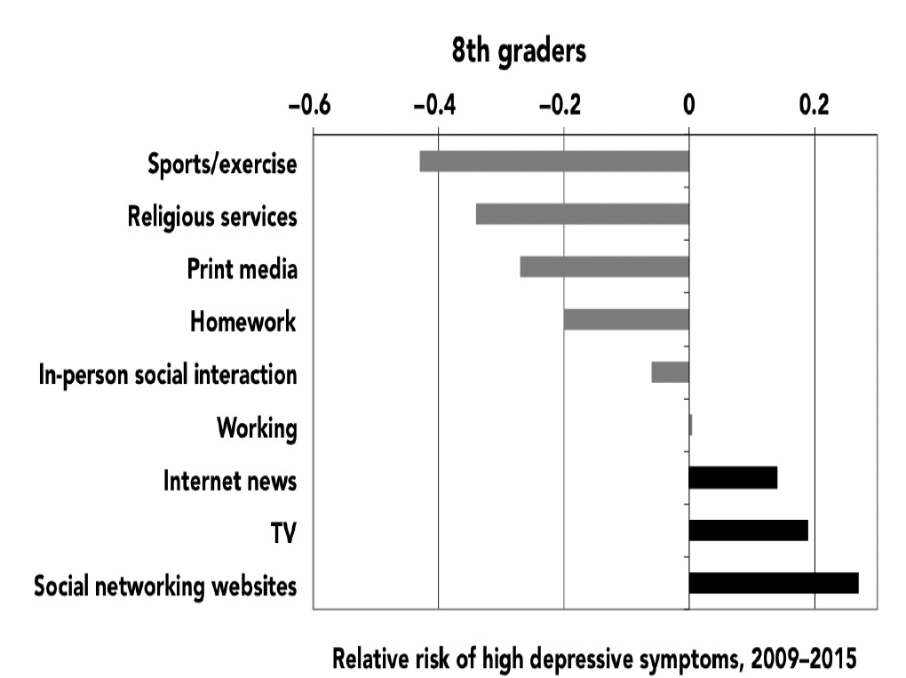
Figure 3.8. Relative risk of high depressive symptoms based on time spent on screen (black bars) and nonscreen (gray bars) activities, 8th graders, 2009–2015.

Younger teens are more at risk for depression connected to heavy social media use. For 10th graders, social media use carries about even odds for depression (see Appendix D). At the very least, social networking sites do not spark joy or protect against depression the way nonscreen activities do; they don’t help and, especially among younger teens, actually hurt.
Ben, 18, lives in Champaign, Illinois, not far from the flagship campus of the University of Illinois. When I reach him one late-August morning, he’s just four days away from beginning his freshman year at a private college in the Northeast. He’s a bookworm who is happy to be heading to a place that takes academics seriously. We chat about the challenges of packing to go away to college and then turn to the topic of social media. “I got my first Facebook [page] at 13,” he says—the minimum age set by the site. “Of course, everyone else already had one.” At that age, he says, social media was a fraught experience. “When I posted stuff, I was always incredibly anxious. I would sit there refreshing to make sure there were likes and stuff,” he says.
“Now my relationship with social media is pretty different. I definitely have more self-confidence, and as a result I sort of care less what people think of my social media. And as a result I basically don’t use it.” He has hit on three truths about social media and teens: their effects on mental health seem to be strongest for the youngest teens, social media can inflame anxiety among those who are susceptible, and those who truly crave the “hit” of likes are often those who are the most vulnerable to mental health issues.
Googling “Facebook and depression” brings up a long list of pages, including a chat board titled “I think Facebook makes me depressed.” MissingGirl, who gives her age as 16 to 17, writes, “Definitely it makes me depressed. All my friends share the fun details of their glamorous lives and it makes me feel like ****. Kinda hate FB.” A poster on Reddit wrote, “Scrolling through my feed, seeing [my friends] being happy makes me sad. Also because . . . I get no messages . . . . The sight of a message box with no notifications gives me a really sad, gut wrenching feeling of loneliness. Facebook depresses me, so I’m going to stop using it.”
Depression is not just a sad mood: if it leads someone to contemplate suicide, it can be physically dangerous as well. The YRBSS (the high school survey administered by the Centers for Disease Control and Prevention) assesses suicide risk, measured by answering “yes” to at least one of the following: feeling very sad and hopeless for two weeks, seriously considering committing suicide, making a plan to commit suicide, or having attempted to commit suicide.
Once again, the link between screen time and mental health issues is distressingly clear: teens who spend more than three hours a day on electronic devices are 35% more likely to have at least one suicide risk factor (see Figure 3.9). That’s much more than the risk related to TV watching, suggesting that it’s not just screens but new media such as smartphones, games, and social media that are behind the link. Nonscreen activities such as exercise instead lower suicide risk factors. So teens who spend a lot of time looking at their phones aren’t just at higher risk of depression—they are also at an alarmingly higher risk for suicide.
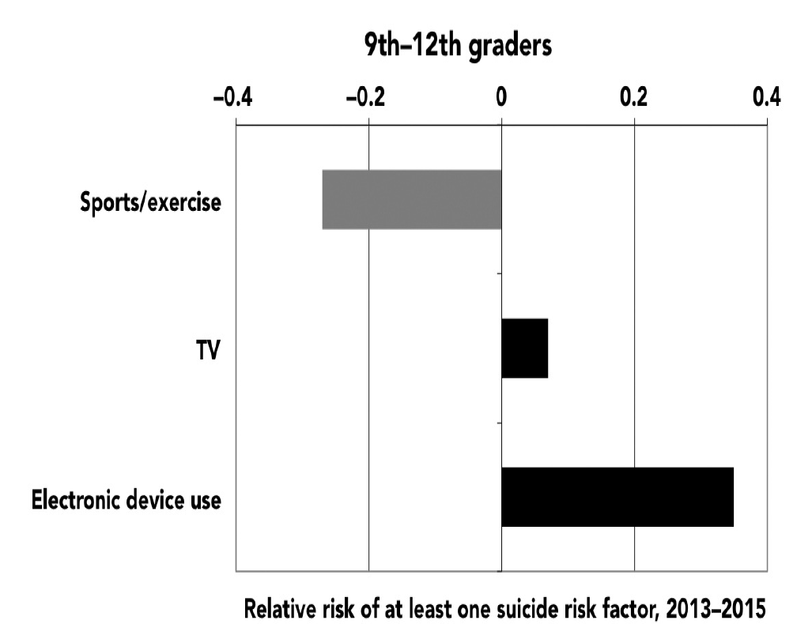
Figure 3.9. Relative risk of having at least one suicide risk factor based on time spent on screen (black bars) and nonscreen (gray bars) activities, 9th–12th graders. Youth Risk Behavior Surveillance System, 2013–2015. (Electronic devices include smartphones, tablets, video games, and computers.)

These analyses show that three hours of screen time a day increases the chance that a teen will be at risk for committing suicide. So how much screen time is too much? Risks start to increase with screen time of two hours or more a day and go up from there, with very high levels of use (five or more hours) linked to considerably higher risks of suicide and unhappiness (see Figure 3.10). This suggests that moderation, not necessarily a complete elimination of electronic devices from teens’ lives, is the key.
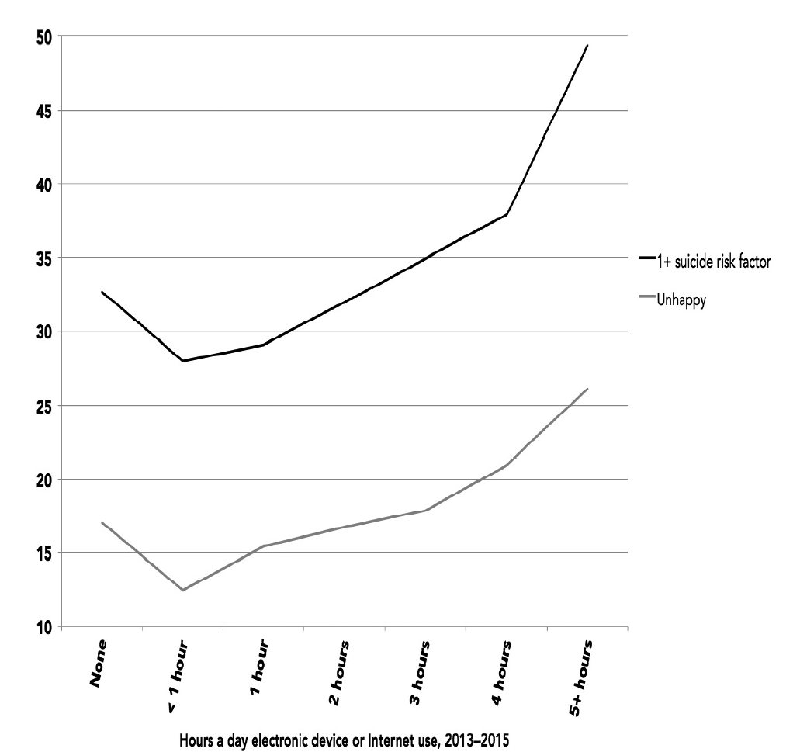
Figure 3.10. Percentage with at least one suicide risk factor and percentage unhappy by hours a day spent on electronic devices or online (exposure-response curve), 9th–12th graders (Youth Risk Behavior Surveillance System), and 8th, 10th, and 12th graders (Monitoring the Future), 2013–2015.

Why is electronic device use linked to such heightened odds of suicide risk? It’s not demographics; the odds look virtually identical when gender, race, and grade are taken into account. It could be that teens at risk for suicide are drawn to electronic devices. Perhaps, but you’d think that those teens, who are often depressed, would be more drawn to passive activities such as TV rather than interactive ones such as social media and computer games. So what, specifically, is so bad about electronic devices that is so much worse than TV? One factor is cyberbullying.
Bullying has always been one of the biggest risk factors for suicide among teens, so it’s not surprising that kids who are bullied at school are twice as likely to have at least one suicide risk factor such as considering suicide or making a suicide plan. However, cyberbullying— electronic bullying via texting, social media, or chat rooms—is even worse (see Figure 3.11).
Two-thirds (66%) of cyberbullied teens have at least one suicide risk factor, 9% more than those who were bullied offline at school. Teens who are cyberbullied often say that there’s no way to get away from their tormentors—unlike with in-person bullies, they can’t just avoid certain people. Unless they give up their phones entirely, the bullying continues.
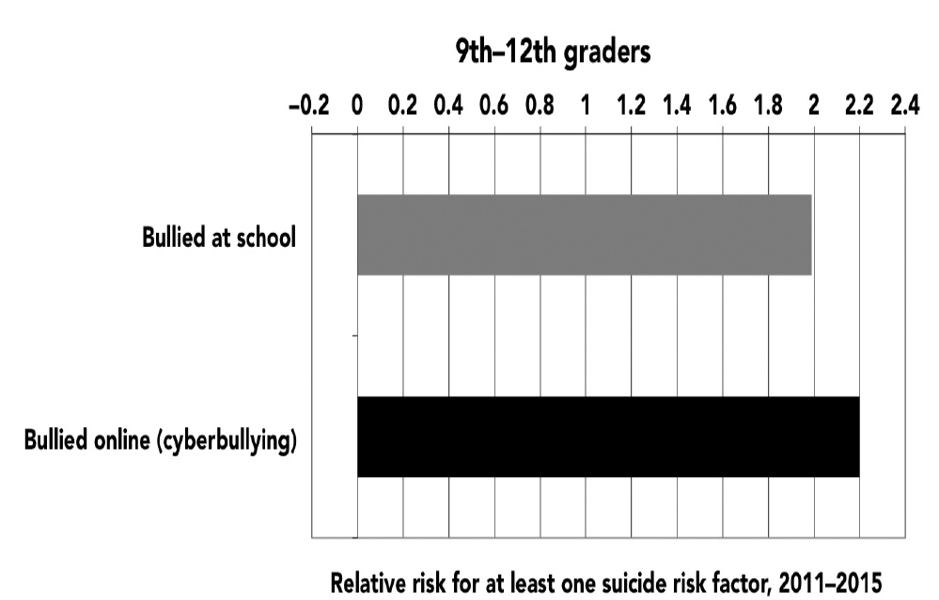
Figure 3.11. Risk of having at least one suicide risk factor based on cyberbullying (black bar) and school bullying (gray bar), 9th–12th graders. Youth Risk Behavior Surveillance System, 2011–2015.

“They said, ‘Nobody likes you, go kill yourself,’ ” 15-year-old Sierra from Virginia said in American Girls about the girls who cyberbullied her. She received one Instagram comment that read, “You have no ass girl, stop trying to take pictures like you have one, it’s not cute, you look like a ho. You look stupid . . . that outfit makes you look like a cheap prostitute that stands on the corner.” The constant bullying sent Sierra into a tailspin. “I started eating ice cream all the time to not let it all get to me, but I don’t want to get fat. So I just solved it by cutting,” she said, referring to self-injury (which involves purposefully cutting yourself with a knife or razor blade, usually on the legs and arms). Eventually, she tried to kill herself, first by swallowing as many pills as she could find and later by jumping in front of an oncoming car. A friend grabbed her and pulled her back.
David Molak was a high school sophomore at Alamo Heights High School in San Antonio, Texas, when his classmates began relentlessly bullying him through text messages, denigrating his physical appearance and hurling other insults. On January 4, 2016, he committed suicide. “I saw the pain in David’s eyes three nights ago as he was added to a group text only to be made fun of and kicked out two minutes later,” his older brother Cliff wrote in a Facebook post. “He stared off into the distance for what seemed like an hour. I could feel his pain . . . . David had been enduring this sort of abuse for a very long time. In today’s age, bullies don’t push you into lockers . . . they cower behind user names and fake profiles from miles away constantly berating and abusing good, innocent people.”
Even when cyberbullying doesn’t lead to suicide, it can certainly lead to unhappiness or depression. Even famous and successful iGen’ers are not immune. Gabby Douglas, the Olympic gymnast who won gold in the all-around competition at the 2012 Games, was cyberbullied after a disappointing performance in 2016. “I wonder how many times I cried. Probably enough to fill so many gallons of water. And it would be like, deep, emotional cries because I was so hurt,” the 21-year-old told People magazine. One set of studies by the Cyberbullying Research Center suggests that cyberbullying has become more common, with 34% of teens in 2016 affected, compared to 19% in 2007. Teens’ entire lives are online, and one out of three is being bullied right where he or she lives.
There’s one last piece of data that indirectly but stunningly captures the move away from inperson activities and toward solo, online interaction. Since 2007, the homicide rate among teens has declined, but the suicide rate has increased. The steady decline in teen homicide from 2007 to 2014 looks very similar to the decline in in-person social interaction (see Figure 3.12). As teens have spent less time with one another in person, they have also become less likely to kill each other. In contrast, teen suicide rates began to tick up after 2008. The rise looks small on the graph because of the scale, but it’s not—46% more teens killed themselves in 2015 than in
2007. The rise occurred just as new-media screen time started to increase and in-person social activities began to wane. In 2011, for the first time in twenty-four years, the teen suicide rate was higher than the teen homicide rate. The gap grew larger from 2011 to 2014, with the suicide rate 32% higher than the homicide rate by 2014—the largest gap since records have been kept (the gap remained high, 30%, in 2015).
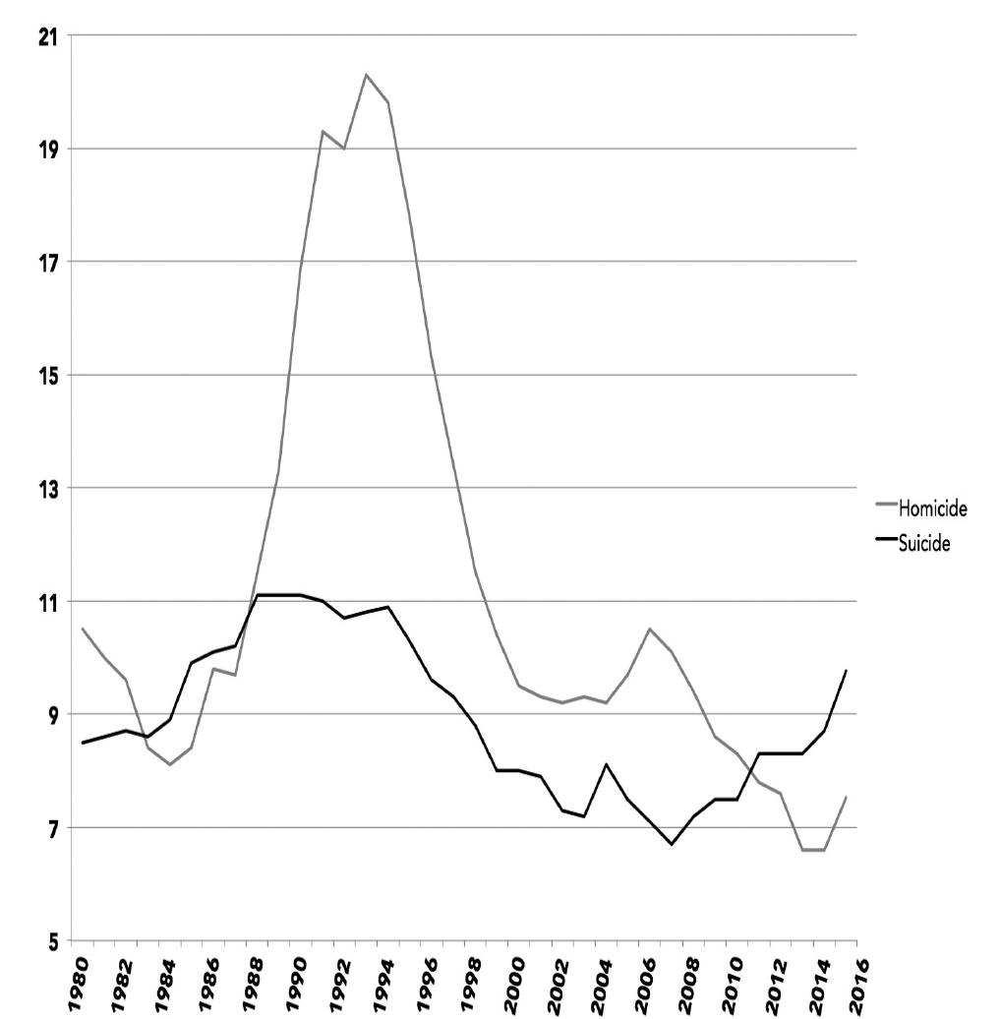
Figure 3.12. Homicide and suicide rates out of 100,000 population among 15- to 19-year-olds, 1980–2015. Centers for Disease Control and Prevention.

The astonishing, though tentative, possibility is that the rise of the smartphone has caused both the decline in homicide and the increase in suicide. With teens spending more hours with their phones and less with their friends, more are becoming depressed and committing suicide and fewer are committing homicide. To put it bluntly: teens have to be with each other in person to kill each other, but they can cyberbully each other into suicide through their phones. Even if bullying is not involved, screen communication can be isolating, which might lead to depression and sometimes suicide. Of course, there are many causes of depression and suicide—too much technology is clearly not the only cause (after all, the suicide rate was even higher in the 1990s, long before smartphones existed). At the same time, it is distressing, and unacceptable, that so many more teens are killing themselves than did just a few years ago.
Discussion Questions:
- In statistics, they teach you “correlation doesn’t mean causation.” However, the seems to argue that excessive screen time causes unhappiness. Do you find her argument convincing? If so, why? If not, why?
- How might this article inform the way we view the current mental health crisis in America?
- The author suggests levels of unhappiness increase dramatically when you spend merely six hours on social media a week. How might we help a friend see the negative impact excessive screen time has on his or her life?
- The biblical worldview suggests we resist AND replace harmful behaviors (Gal. 5:16, Eph. 5:18). What are some practical things we can do to break our screen time addiction?

